Smart Public Restroom

Naan Mudhalvan Phase 1 Project

712521104014 – Kaviyarasan.E



**Project Title:** Smart Public Restroom

**Phase 1:** Project Definition and Design Thinking

**Project Definition:** The project aims to enhance public restroom management by installing IoT sensors to monitor occupancy and maintenance needs. The goal is to provide real-time data on restroom availability and cleanliness to the public through a platform or mobile app. This project includes defining objectives, designing the IoT sensor system, developing the restroom information platform, and integrating them using IoT technology and Python.

**Design Thinking:**

Project Objectives: Define objectives such as real-time restroom availability information, cleanliness monitoring, improved user experience, and efficient restroom.

IoT Sensor Design: Plan the deployment of IoT sensors (e.g., occupancy sensors, cleanliness sensors) in public restrooms.

Real-Time Transit Information Platform: Design a web-based platform and mobile app to display real-time restroom availability and cleanliness data.

Integration Approach: Determine how IoT sensors will send data to the restroom information platform.

**Objectives:**

* Provide real-time restroom availability information to the public
* Monitor restroom cleanliness and alert maintenance staff when needed
* Improve the user experience of public restrooms
* Make public restrooms more efficient and cost-effective

This project will include the following steps:

**Design the IoT sensor system:** What type of IoT sensors will we need? Where will we deploy them in the restroom? How will they collect and transmit data?

**Develop the restroom information platform**: What features will the platform have? How will it display real-time restroom availability and cleanliness data to the public?

**Integrate the IoT sensor system and the restroom information platform:** How will the IoT sensors send data to the platform? What programming languages and tools will we use to build the integration?

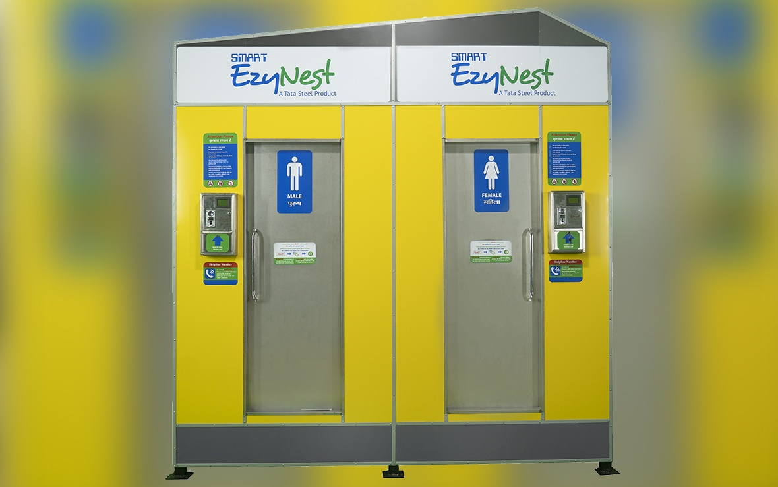

*Smart Public Restroom*

***Design Thinking***

* Design thinking is a non-linear, iterative process that teams use to understand users, challenge assumptions, redefine problems and create innovative solutions to prototype and test.
* To apply design thinking to this project, we would start by conducting user research to understand the needs and pain points of public restroom users. We would then use this information to brainstorm and develop ideas for how to improve the public restroom experience.
* Once we have a few ideas, we would build prototypes and test them with users to get feedback. This feedback would help us to refine our ideas and develop a final solution.

***Project Objectives***

* Real-time restroom availability information: Users should be able to access real-time information on the availability of restroom stalls, showers, and other amenities.
* Cleanliness monitoring: The system should monitor the cleanliness of restrooms and alert maintenance staff when needed.
* Improved user experience: The system should make it easier for users to find and use public restrooms.
* Efficient restroom: The system should help to make public restrooms more efficient and cost-effective.

***IoT Sensor Design***

Type of sensors: What type of IoT sensors will we need to achieve our project objectives? Some possible sensors include:

Occupancy sensors: To detect whether a restroom stall or shower is occupied

Cleanliness sensors: To detect whether a restroom stall or shower is clean

Environmental sensors: To monitor temperature, humidity, and other environmental conditions in the restroom

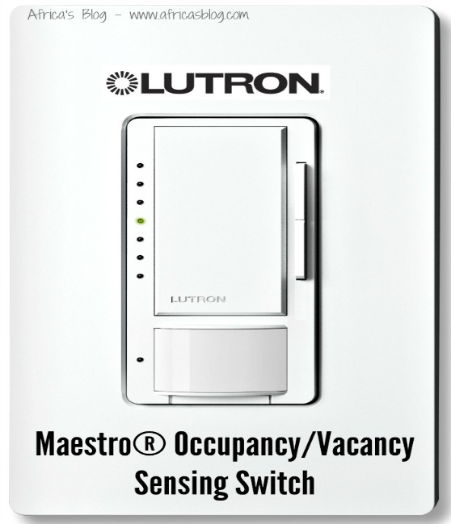

**Deployment**: Where will we deploy the IoT sensors in the restroom? We need to consider factors such as power availability, communication coverage, and sensor placement to ensure that the system is effective.

**Data collection and transmission:** How will the IoT sensors collect and transmit data? We need to choose the right communication protocol for the environment and the type of data being transmitted.

**Real-Time Transit Information Platform:**

The real-time transit information platform will display real-time restroom availability and cleanliness data to the public. The platform could be a web-based application or a mobile app.

The platform should include the following features:

* Real-time restroom availability information: The platform should display the real-time availability of restroom stalls, showers, and other amenities.
* Cleanliness monitoring: The platform should display the cleanliness status of restrooms.
* User interface: The platform should have a user-friendly interface that makes it easy for users to find and use the information.

***Integration Approach***

The IoT sensor system and the real-time transit information platform need to be integrated so that the sensor data can be displayed on the platform.

There are a few different ways to integrate the two systems. One approach is to use a cloud-based IoT platform. Cloud-based IoT platforms provide a way to connect IoT devices to the cloud and manage them remotely.

Another approach is to develop a custom integration solution. This approach would involve writing code to connect the IoT sensors to the real-time transit information platform directly.

The best integration approach will depend on the specific requirements of the project.

***Next steps:***Once we have completed the project definition and design thinking phase, we can start to develop a detailed project plan. The project plan should include timelines, milestones, and budgets.

We should also start to identify and procure the necessary hardware and software components.

In summary, the "Smart Public Restroom" project represents a forward-thinking solution to a common urban challenge. By providing real-time information and improving restroom management, this project has the potential to enhance the quality of life for residents and visitors alike, making public restrooms more accessible, efficient, and pleasant to use.

***Thank you….***

***Done by:***

***Kaviyarasan.E***